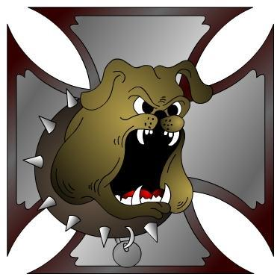
DOGGs
Is a group of Dallas Oregon Old Guys and Gals that are interested in wholesome motorcycle fun. Don't let our name fool you, we are made up of a variety of ages and bikes. We meet the first Tuesday each month at 7:00PM at “LOCATION TBD”
https://www.facebook.com/groups/doggs.members/
Feb 21; Chilly Buns Roll and Ride. Bottle Factory, Stayton 10am.
Mar 2; DOGGs Meeting??
Mar ??; ABATE Swap Meet, Milwaukie, Or.
Apr 6; DOGGs Meeting??
Apr 18; DOGGs 16th Anniversary Ride and Silent Auction??
Apr 24-25 ; ABATE Swap Meet, Pottsville. 9-5.
May 4; DOGGs Meeting.
May 9; DOGGs Sunday Ride (Mothers Day).
May ?? : Salem HD Swap Meet.
May 18; Dinner social/DOGG Chow??
May 28-31; Fossil Campout.
May ??; Sweeneys 4th annual Poker Run.
May 30; OVM Swapmeet and Bike Show, Corvallis.
May 31; Memorial Day.
Jun 4-6; Spring Street Vibrations. Reno, Nevada.
Jun ?? ; Hub City ABATE Poker Run. Albany.
Jun 1; DOGGs Meeting.
Jun 6; DOGGs Sunday Ride.
Jun 15; Dinner social/DOGG Chow.
Jun ??; Wallowa Run. Joseph, Oregon.
Jun ??; Shovelfest-West Campout. O’Brian.
Jul 3; Ride and BBQ!!!
Jul 6; DOGGs Meeting.
Jul ; Jim’s ‘Where ever the hell I wanna go’ Run!
Jul 10-12; DOGGs 2niter? Eastern Oregon? Mt St. Helen’s?
Jul ??; Hells Canyon Rally, Baker City, Or.
Jul 15-18; Pendleton Bike Week.
Jul ??; Run 21, Otis.
Jul 20; Dinner social/DOGG Chow.
Jul ??; Salem HOG, Rally in the Valley.
Jul 30-Aug 1; Southern Oregon Summer Run.
Aug 4; DOGGs Meeting.
Aug 6-15; Sturgis.
Aug 17; Dinner Ride.
Aug 24-27; 3 DOGG niter! Woof Woof!!!!
Sep 7; DOGGs Meeting.
Sep 7-9; End of Summer 2-niter?
Sep 14; Dinner Social/DOGG Chow.
Sep ??; Anacortes, Wa Oyster Run.
Sep 23-26; Street Vibrations, Reno, Nevada.
Ride Safe and have fun!! EEEEHAAAA!!!!

